**Ideation Phase**

**Define the Problem Statements**

|  |  |
| --- | --- |
| Date | 19 September 2022 |
| Team ID | PNT2022TMID50120 |
| Project Name | Project – Inventory Management System for Retailers |
| Maximum Marks | 2 Marks |

**Customer Problem Statement**

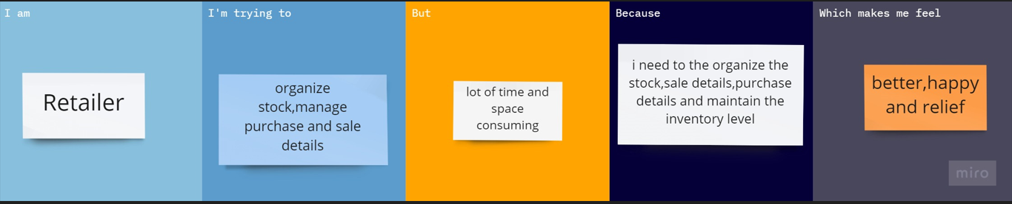

Reference : <https://miro.com/app/board/uXjVPTsy3pY=/>

|  |  |  |  |  |  |
| --- | --- | --- | --- | --- | --- |
| **Problem Statement (PS)** | **Iam (Customer)** | **I’m trying to** | **But** | **Because** | **Which makes me feel** |
| PS-1 | Retailer | Find the high demand products. | it’s difficult to calculate | it takes more time | Challenging. |
| PS-2 | Retailer | find the customer’s review | it’s hard to gathering information | i don’t have enough contacts | disappointed |
| PS-3 | Retailer | calculate the bill for transportation purpose | it’s hard | it takes long time | uninterested |
| PS-4 | Retailer | maintain the ledger | it’s difficult to secure | it may be lost | afraid |
| PS-5 | Retailer | find the products count in the stock | it’s difficult | it takes more time | tired |